Long Quiz No. 2
(2nd Grading Period)

NAME:__________________________________ SCORE:____________
YR. & SEC.______________________________ DATE:_____________

DIRECTIONS: Write the letter of the best answer before each number. Answers must be simplified with the correct unit.

1. If f(x) = 2x + 3 and g(x) = x² − 3x − 1, then what is f(x) + g(x) ?
A. 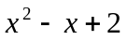 C. 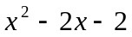
B. 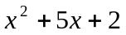 D. 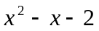

2. What is the remainder if the polynomial 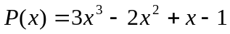 is divided by x – 2?
A. 10 B. 13 C. 15 D. 17
3. Consider the polynomial function f(x) = 5 – x³. What is the function value at x = − 3?
A. – 4 B. 14 C. 22 D. 32

4. What is the value of g ( − 2 ), if g(x) = 5x – x ³ .
A. – 16 B. 16 C. – 2 D. – 4

5. Which of the following relations defines a constant function?
A. y = 5 B. y = x C. x = 5 D. y = x²

6. What is the domain of the function f(x) = 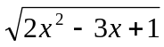 ?
A. 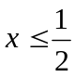 or 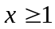 C.  < x < 1
B. 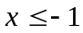 or 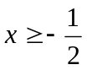 D. x 1

7. What is the range of the function defined in number 6?
A. 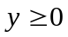 B. y > 0 C. all real numbers D. positive integers

8. Let f 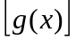= 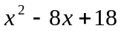, and g(x) = x – 4 , what is f(x) ?
A. 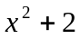 B. 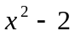 C. 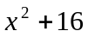 D. 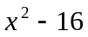

9. What is the quotient Q(x) when P(x) = 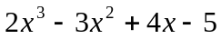 is divided by (x + 1)?
A. 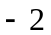x + 5 B. 2x² + 5x C. 2x² + 9 D. 2x² − 5x + 9

10. If 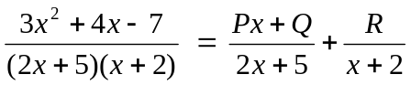, then what are the values of P, Q, and R?

A. P = 3, Q = 4, R = – 3 C. P = 3, Q = 4, R = 3
B. P = – 3, Q = – 4, R = – 3 D. P = – 3, Q = 4, R = – 3

11. Which of the following is a factor of the polynomial 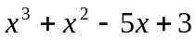 ?
A. x + 1 B. x + 2 C. x + 3 D. x – 2

12. What is the quotient and the remainder when 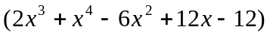 is divided by
( 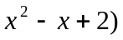?
A. Q(x): 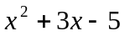; R(x): x – 2 C. Q(x): 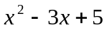; R(x): x – 2
B. Q(x): ; R(x): x + 2 D. Q(x): ; R(x): x + 2

13. Which of the following defines a linear function?
A. 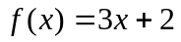 C. g(x) = ( x – 4 )( x – 4)
B. 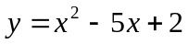 D. 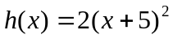

14. What binomial of lowest degree must be multiplied to 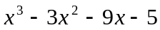 to make it a polynomial
with perfect root?
A. x+5 B. x – 5 C. x – 1 D. x + 1

15. The graph of the function 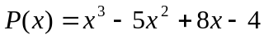 is tangent to the x – axis at what point?
A. ( − 2, 0 ) B. ( 2, 0 ) C. (1, 0 ) D. ( − 1, 0 )

16. What is the upper bound for the real zeros of the polynomial function 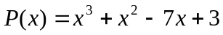
A. 2 B. 3 C. 4 D. 5

17. Given that the graph of the polynomial function defined by 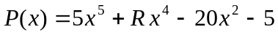
crosses the x – axis between 0 and 1, what is the range of possible values of R ?

A.  B. 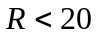 C.  D. 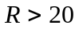

18. If ( 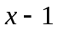) is a factor of the polynomial x² – 2x + 1, which one is the other factor ?
A. (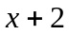) B. (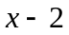) C. (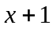) D. ( x – 1 )

19. Consider the growth of a single-celled organism. After an hour, when the organism has gained
enough weight, it divides into two. After another hour, each of the two organisms will divide
again into two, and so on. This situation involving growth shows what kind of change?
A. linear B. quadratic C. exponential D. geometric

20. Using the given situation in number 19, how many organisms would there be after 6 hours?
A. 128 B. 64 C. 32 D. 8

21. The graph of the function P(x) = 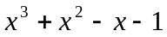 is tangent to the x-axis at what point ? ?
A. ( 1,0 ) B. ( 1, 0 ) C. ( 2, 0 ) D. ( 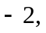0 )

22. What are the zeros of the polynomial function defined in number 21 ?
A. { 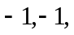1 } C. { 0, 1, 2}
B. { 0, −1, 1} D. { −1, 0, 2 }

23. What should be the value of k so that (x + 1) is a factor of 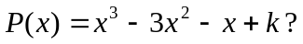?
A. 2 B. 3 C. 4 D. 0

24. The dimensions of a rectangular box are (x + 1) m by (x 1) m by ( x + 2 ) m, respectively.
What is the volume of the box in cubic meters?
A. 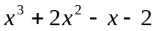 C. 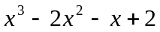
B. 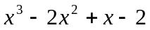 D. 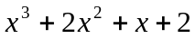

25. Find the equation of a quadratic function whose zeros are 5 and – 3 .
A. 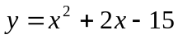 C. 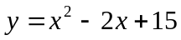
B. 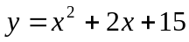 D. 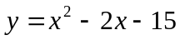

- GOOD LUCK -

